TOPIC 1: STRAIGHT LINE AND SIMPLE CURVE
OBJECTIVES: By the end of lesson, students will be able to:
- Plot simple straight lines and curves.
- Determine the x-intercept, y-intercept and gradients of straight lines.
- Determine the gradient of a curve and draw tangents to a curve at a given point.
For all the plane shapes, the formation remains as a result of the combination of simple straight lines or curves. For polygons, they are simply the connection of straight lines, while shapes like the circle are formed from simple curves. This premise stretches deep into the formation of solid shapes as well.
PLANE POINTS AND EQUATION FORMS OF A STRAIGHT LINE
Whether we are drawing a straight line or a curve, the bare minimum condition to be satisfied is the presence of points which we can plot on the axis. These points are referred to as coordinate points.
For each coordinate point, there is a x-coordinate, also called the ABSCISSA and a y-coordinate also called the ORDINATE. Together, they are written in the form (x,y).
For straight line graphs, they are formed from the plotting of linear equations that have a general form:
y = mx +c ---------------------(*)
where m=gradient
c = y-intercept
Alternatively, the general for can be written as
ax +by + c = 0 ---------------(**)
which can then be converted into (*) above
x-intercept
The x-intercept simply refers to a coordinate point in the form (x, o). That is, it is the value of x when y = 0
y-intercept
This simply refers to a coordinate point in the form (o,y). That is, it is the value of y when x=0
EXAMPLE:
- Find the point of intersection of the line
2x +5y – 3 = 0 with the (a.) x-axis (b.) y- axis
For the x- axis, it suffices to find the x-intercept, that is (x,o)
Then , when y = 0
2x +5y – 3 = 0
2x + 5(0) – 3 = 0
2x – 3 = 0
x= 3/2
thus, the point of intersection of the line with the x- axis is (3/2, 0)
For the y-axis, it suffices to find the y-intercept, i.e. (0,y)
Then, when x =0,
2x +5y – 3 = 0
2(0) +5y – 3 = 0
5y - 3 = 0
y = 3/5
Thus, the point of intersection of the line with the y- axis is (0,3/5)
We can also confirm these values from the graph sheet
- Determine the gradient of the line
2x + 3y + 2 = 0
Given the linear equation, it suffices for us to rewrite it in the form,
Y = mx + c
And then determine the values of the gradient, m.
From 2x +3y + 2 = 0, make y the subject of the formula
3y = - 2x – 2
y = $\frac{-2}{3}x-\frac{2}{3}$
comparing with y = mx + c
m = $\frac{-2}{3}$
we then proceed to confirm these values from the graph sheet.
- Find the point of intersection of the lines
y= 3x +2 and y = 2x + 5
y = 3x + 2 -------(i)
y = 2x + 5 --------(ii)
by elimination,
(i) –(ii) gives
x – 3 = 0
x = 3
substituting x = 3 into (i), we have y =3(3) + 2
y = 11
GRADIENT OF A STRAIGHT LINE
The gradient, m, of a straight line is also referred to as the slope of the straight line. Put blankly, it is the change in the y- coordinates with respect to a corresponding change in the x – coordinates.
Mathematically,
$M=\frac{y_{2}-y_{1}}{x_{2}-x_{1}}$
Where ($x_{1},y_{1}) and \left(x_{2}-y_{2}\right) are any coordinate points of the straight line y=mx+c$
TRIVIA
The gradient of a straight line is also referred to as the Tangent of the angle of slope.
Consider,
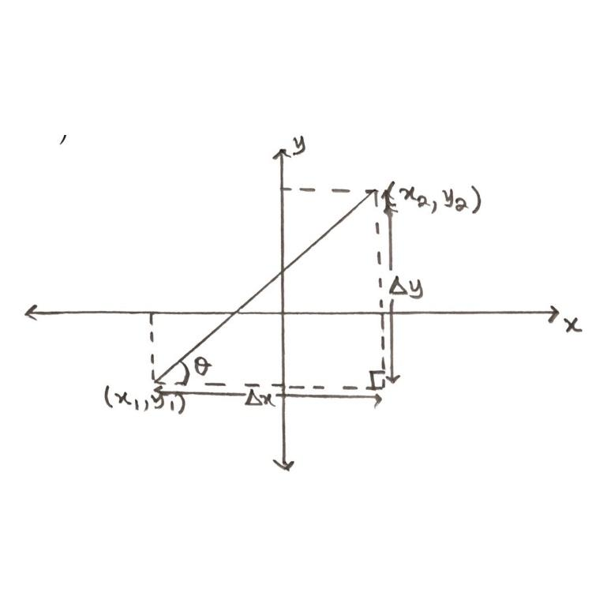

$$∆y=y_{2}-y_{1}; ∆x=x_{2}-x_{1}$$
$M=\frac{y_{2}-y_{1}}{x_{2}-x_{1}}=\frac{ ∆y}{ ∆x}$
Tan $θ=\frac{ ∆y}{ ∆x}$
Thus, m = Tan $θ$
Where $θ=angle of slope of the straight line$
In advance classes, it will therefore follow that the gradient is indeed the “differential of y with respect to x”.
POINT OF INTERSECTION OF STRAIGHT LINES
$a_{1}x+b_{1}y+c_{1}=0-----(i)$
$a_{2}x+b_{2}y+c_{2}=0-----(ii)$
It suffices to solve them simultaneously to obtain the value of x and y to for (x,y). On the graph, the point of intersection, as the name suggests, is the point where both lines overlap or intersect.
Thus, the point of intersection of the two straight line is (3,11)
We can also display this on the graph sheet.
CURVES AND TANGENTS TO CURVE
When we plot coordinate points that tally into a curve, this is due to the fact that the highest power on the independent variable exceeds 1. In essence, plotting a quadratic equation would lead to a curve when plotted.
Just as in straight lines, we can also deduce intercept points for the curves using similar techniques. We can also go further to find points of intersections between a quadratic curve and a linear curve, which is the equivalent of solving both equations simultaneously.
EXAMPLE:
Using the range of values from – 2 to 2 for x, plot the graphs of y = 2 + x - $x^{2}$ and y = -x + 1
From the graphs,
- Deduce the solution for $-x^{2}+x+2=0$
- Find the points of intersection
- Deduce the value of x at the maximum y-coordinate.
- Find the solution of the equation 1 + 2x – $x^{2}=0$
First, we complete the table of values, then we plot on the graph sheet.
x | -2 | -1.5 | -1.0 | -0.5 | 0 | 0.5 | 1.0 | 1.5 | 2.0
y = - x +1 | 3 | 2.5 | 2 | 1.5 | 1 | 0.5 | 0 | -0.5 | -1
y = 2+x- $x^{2}$ | -4 | -1.75 | 0 | 1.25 | 2 | 2.25 | 2 | 1.25 | 0

GRADIENT TRIVIA
While the gradient of a straight line is constant everywhere on the line (i.e. at any two points on the line), the gradient of a curve changes at each point on the curve.
Thus, to find the gradient of the curve at any pint ($x_{1},y_{1}),$ it suffices to find the tangent to the curve at that point and then find the gradient of that tangent.

TANGENT TO A CURVE AT A POINT
The tangent to a curve at a specific point, say ($x_{1},y_{1})$ is a straight line that intersects the curve at ONLY that point ($x_{1},y_{1})$
A similitude can be drawn to the tangent of the circle, since the circle is simply a joined curve.
EXAMPLE:
Draw the curve y = $x^{2}+2x-4$ with x ranging from -4 to 4, and evaluate the gradient at p (+1, -1) and Q(-2, -4) on the curve.

GRADIENTS AT TURNING POINTS
Turning points are the maximum and minimum y- coordinate points on the curve. The gradient of the curve at the turning points are ZERO.
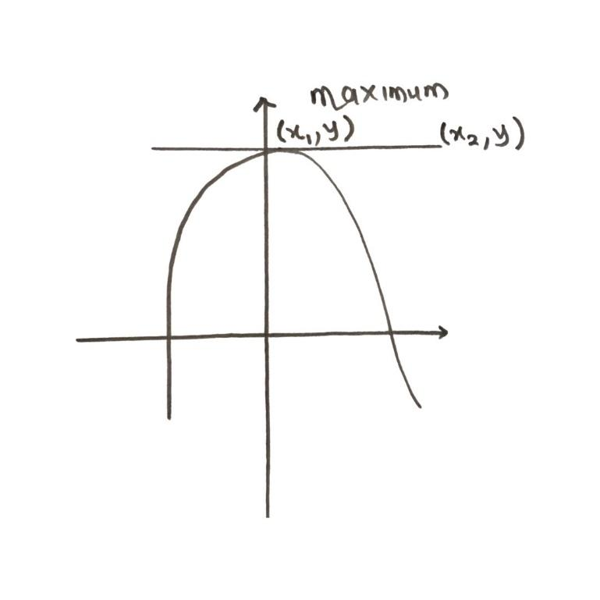

Gradient = $\frac{y_{2}-y_{1}}{x_{2}-x_{1}}$
= $\frac{y-y}{x_{2}-x}$
= 0
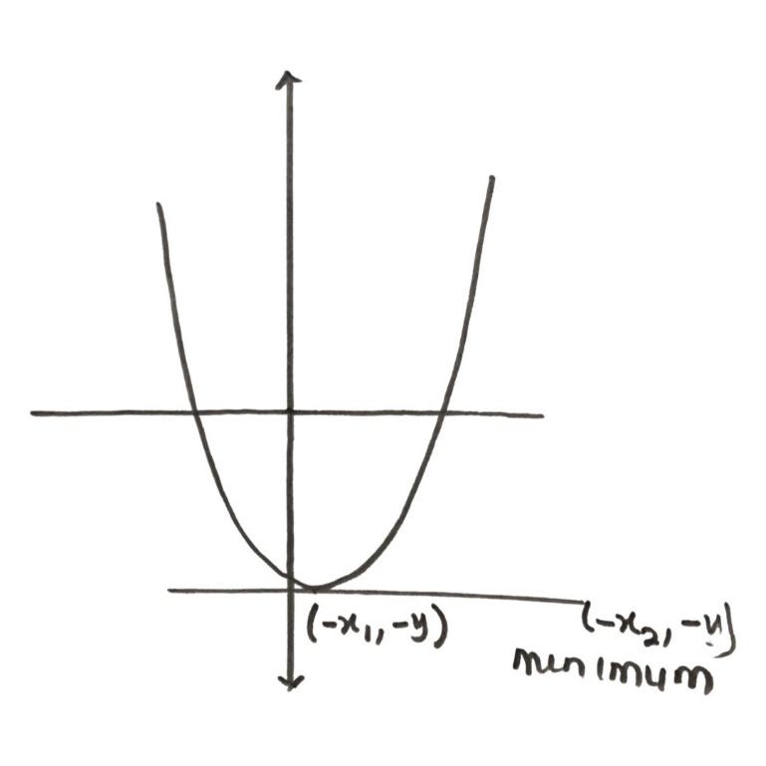

Gradient = $\frac{y_{2}-y_{1}}{x_{2}-x_{1}}$
= $\frac{-y-\left(-y\right)}{-x_{2}-\left(-x_{1}\right)}$
= $\frac{-y+y}{{-x}_{2}+x_{2}}$
= 0
TRIVIA
For quadratic graphs, when the coefficient of $x^{2}$ is positive, the graph gives a U-shape curve.
When the coefficient of $x^{2}$ is negative, the graph gives an $∩-shape curve.$
DRILLS
Plot the equation 4x + 2y = 5 and deduce the:
- x – intercept
- y – intercept
- gradient
Draw the graph of y = $x^{2}-x-2,$ taking the values of x from -3 to 3. On the same axes, plot 2y-4x + 8 =0.

From the graphs,
- Deduce the solution for $x^{2}-x-2=0$
- Find the values of x for which 2($x^{2}-x-2)=4x-8$
- Find the coordinate points ($x_{1},y_{1})$ at the maximum or minimum value of y. Hence, obtain the gradient at that point.
- Find the gradient of the straight line 2y – 4x +8 = 0 and the slope of the curve
y = $x^{2}-x-2$ at (1, -2).

